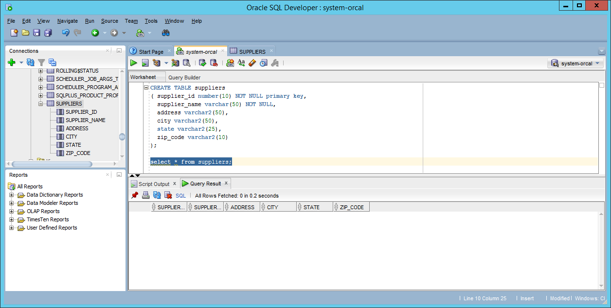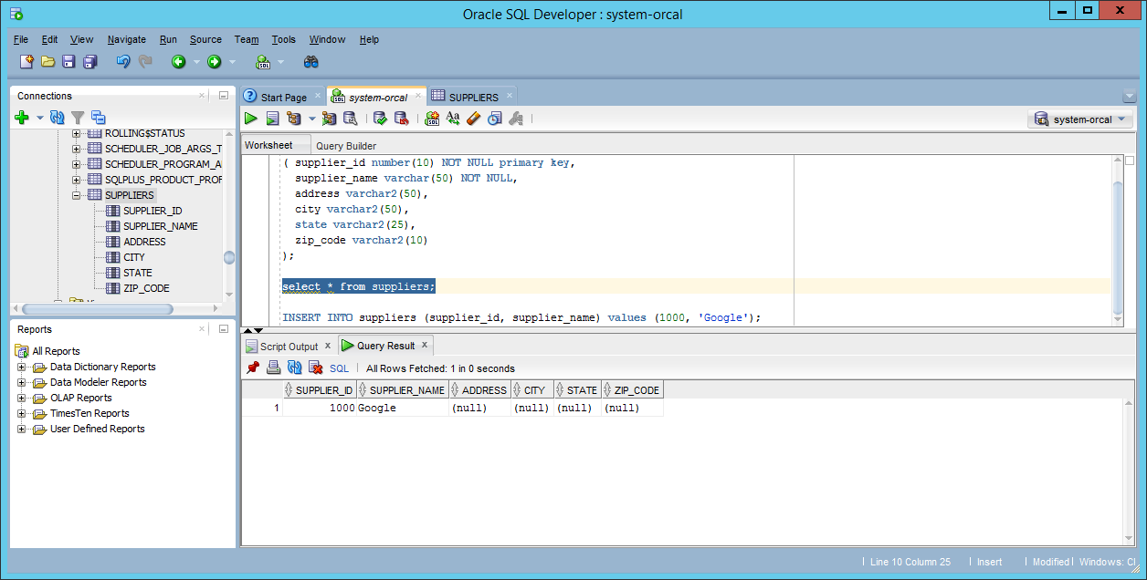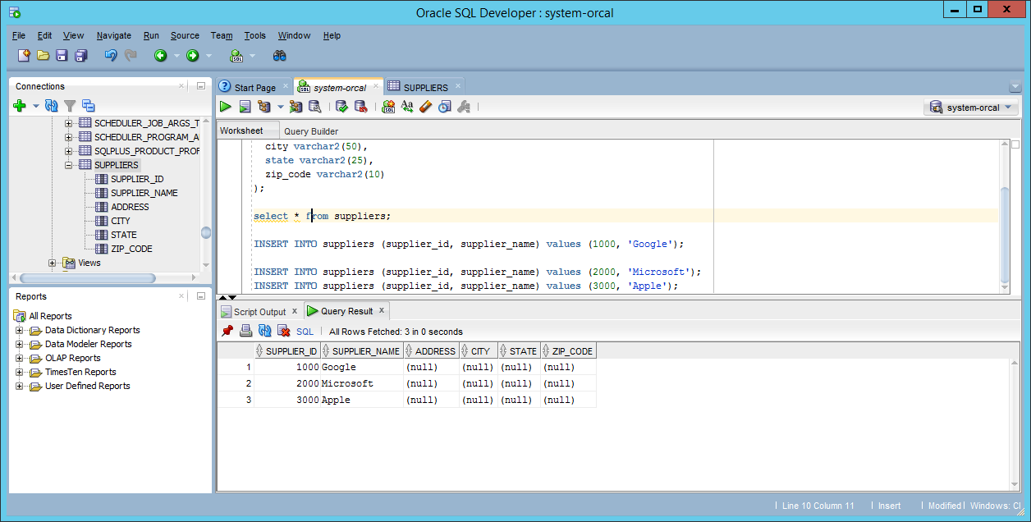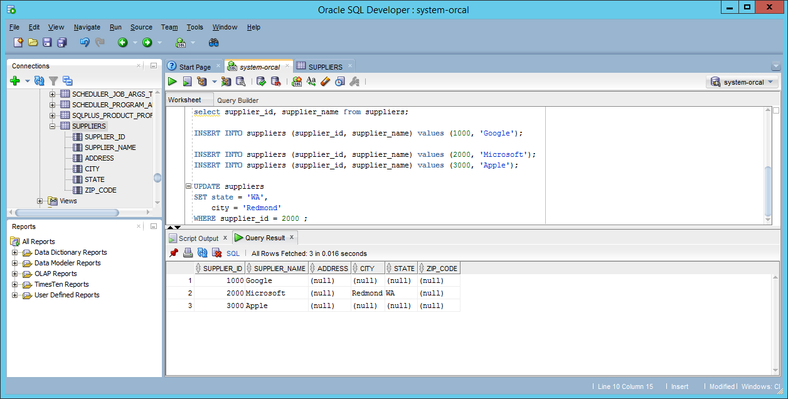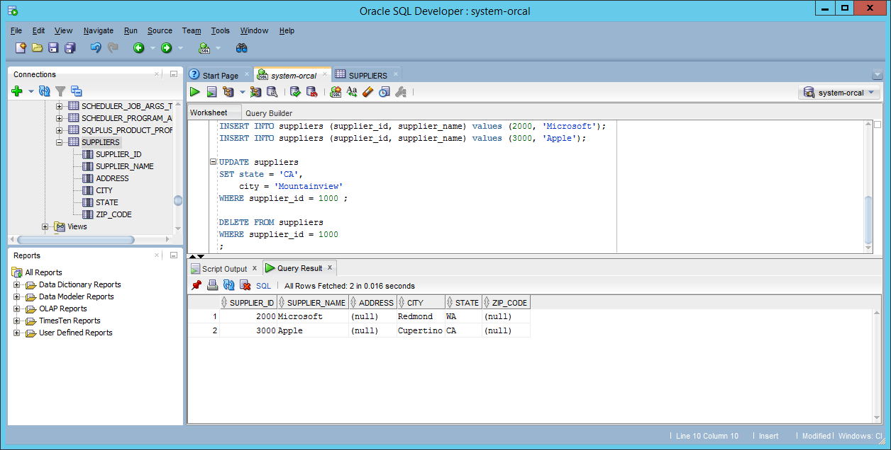CREATE TABLE suppliers
( supplier_id number(10) NOT NULL primary key,
supplier_name varchar(50) NOT NULL,
address varchar2(50),
city varchar2(50),
state varchar2(25),
zip_code varchar2(10)
);

select * from suppliers;

select supplier_id, supplier_name from suppliers;

INSERT INTO suppliers (supplier_id, supplier_name) values (1000, 'Google');
INSERT INTO suppliers (supplier_id, supplier_name) values (2000, 'Microsoft');
INSERT INTO suppliers (supplier_id, supplier_name) values (3000, 'Apple');

UPDATE suppliers
SET state = 'CA',
city = 'Mountainview'
WHERE supplier_id = 1000 ;

DELETE FROM suppliers
WHERE supplier_id = 3000
;

